附件：
公告认领的车辆清单
序号 | 车牌号 | 图片
1 | 贵A55YT8 | 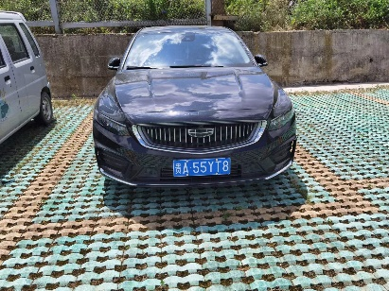
2 | 贵A85NEI | 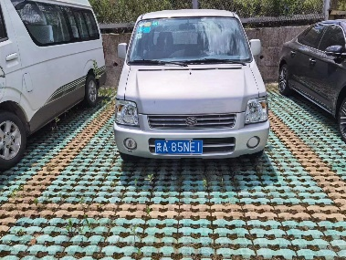
3 | 贵A90PY2 | 